

**American International University- Bangladesh**

**CSC 3215: Web Technologies**

**CO1 and CO3 Evaluation**

**Project Report**

**Spring 2019-2020**

**Project Title: Tazker – Project Planning and Collaboration**

**Section: A**

|  |  |
| --- | --- |
| Student Name | Student Id |
| Anzum Kazi Tamrin | **17-34920-2** |
| Dip Shafiul Alam | **17-34827-2** |

**Introduction:**

In our real-life scenario, we work in many projects or somehow involved in many projects, but in an undisciplined way. We do not maintain our workflow or keep tracks so we cannot see the project overview

Or current state we’re in, team collaboration also done in a messy way. So, the project named ‘Tazker’ helps us to create projects and associate individuals and distribute tasks or collaborate and keep track, all in one place

**Background Study**

The project idea came from observing various websites and web-applications, such as Slack, Trello, Microsoft Teams etc.

**Requirement Analysis:**

1. **User Category:**

There are 4-types of Users here. They are:

* Super Admin
* Admin
* Project Holder
* Team Members

1. **Feature List:**

In this project the “Super Admin” has the following features:

* Modify everything
* Add or Remove individuals permanently

In this project the “Admin” has the following features:

* Sees application insights
* Sees projects overview sitewide
* Sees traffic information’s
* Sees newly registered members

In this project the “Project Holder” has the following features:

* Create a plan/project
* Assign team leads
* Fixes deadline for the project
* Sees project insights and Information’s

In this project the “Team Lead” has the following features:

* Create teams
* Assign individuals or members
* Create dynamic task boards and order them in a sequence
* Create tasks in individual task boards
* Fixes deadline for the tasks

In this project the “Project Member” has the following features:

* Can see projects he got assigned into.
* Can see task boards of the projects
* Can see the tasks card per board
* Modify the task cards (Task progress, Comment, Move to another board)
* Collaborate

**Design:**

Entity relationship diagram for the project:

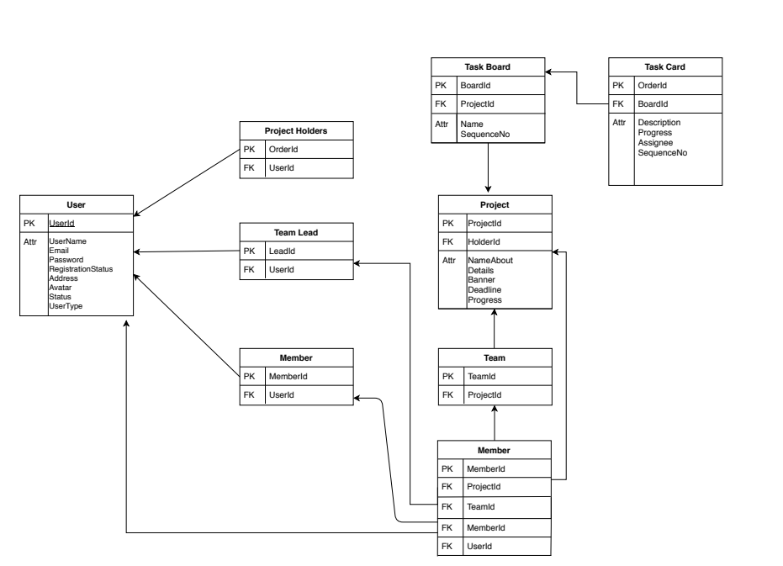

**Tools Used:**

To develop this project, we have used the following:

• Apache as Web Server

• MySQL as database.

• HTML as markup language.

• Bootstrap and CSS for designing.

• jQuery and JavaScript for DOM manipulation.

• PHP as programming language

**System Images against the Specification:**

Screen shot of some GUIs (Midterm project)

**Log In**

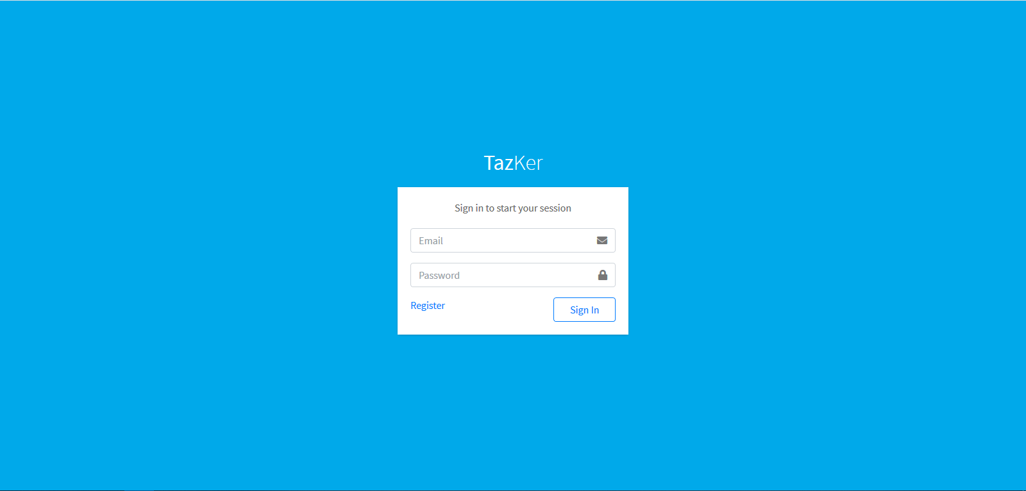

**Different types of users can log in using this single login page.**

**Registration**

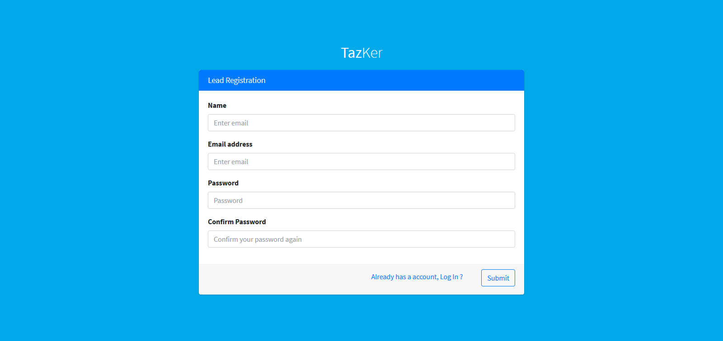

**Users can do registration from this page, basically the project holders.**

**Dashboard**

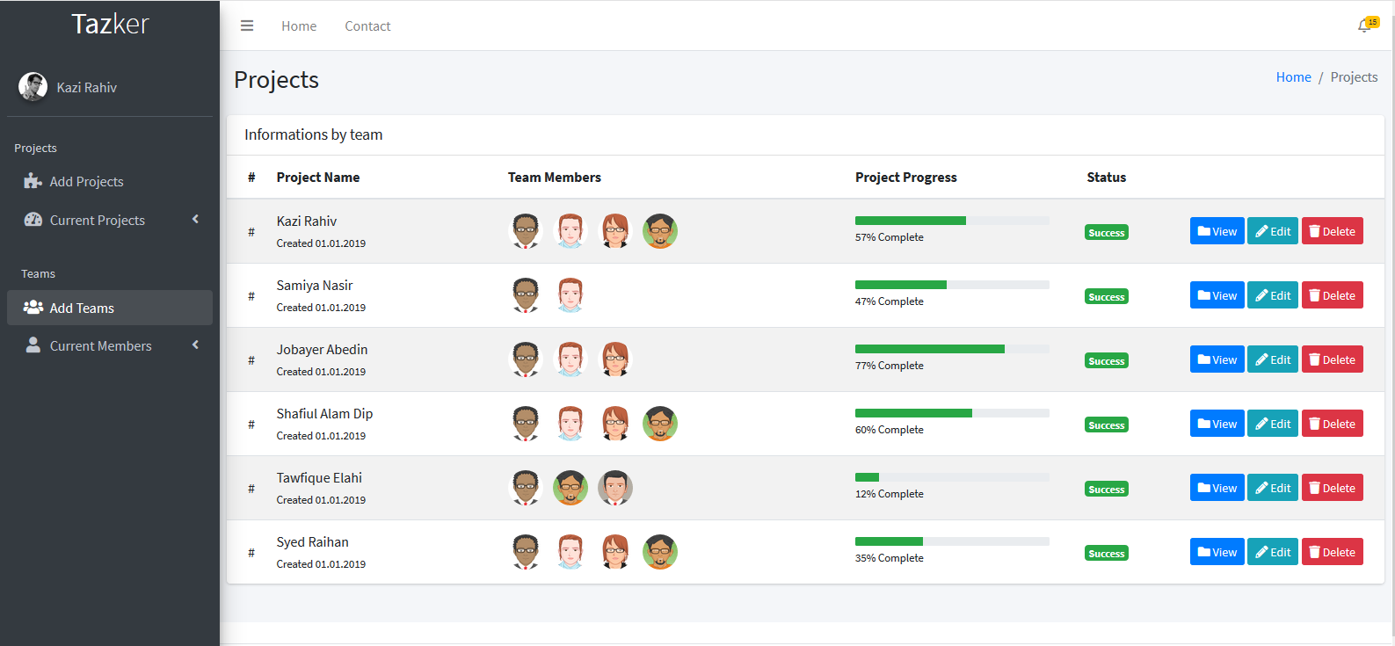

**Dashboard for the users.**

**Add Project**

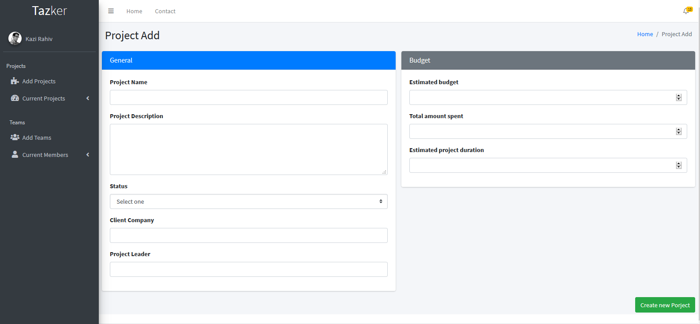

**Impact of this Project:**

Describe the increasing importance of your project on modern society and environment.

How will people be benefitted from your project?

The importance of the project is, Now the project management will be done in a structured mannered where each and everyone is tracked and the information is tracked. The collaboration management is also easy so solving our real-life problems with this will get very easy.

**Limitations and Possible Future Improvements:**

* API integration for extending and use information from this application to others.
* Breaking down this project into microservices for scalability and larger improvements.
* Payroll implementation
* Payment gateway implementation.
* Mobile application version for managing on the go!

|  |  |  |  |  |  |
| --- | --- | --- | --- | --- | --- |
| **CO1 and CO3 Evaluation: Project Report Evaluation** | | | | | |
| **Project Proposal**  **(5)** | **Background**  **Study**  **(5)** | **Requirement Analysis**  **(5)** | **Entity**  **Diagram**  **(5)** | **System Images**  **against the**  **Specification (5)** | **Total (25)** |
|  |  |  |  |  |  |
|  | | | | | |